Core Text **C1 C2 C4 C5 C6 C7 C8 C9 C10 C12**

**Big Questions**

Science

History – **H2 3 4 6 7 13 16 17**

**Scripture Focus:**

**Prayer Focus** **– Yr2 Traditional Prayers**

**Fantastic Finish**

**English**

Other Texts

Writing Opportunities– **CE1/ CE2/CE3/CE5/CE7/VPG7/VPG9/**

Computing – 4,5,7

**Creating a topic based e-book**

Maths –Money, Multiplication and Division. Length and height, Mass, Capacity and Temperature.

NCTEM – Maths Mastery

**R.E.**

**SMVSC**

Gospel values

P.E. 1,2,3

**Stunning Start**

Art – **A1 2 3 4 5 6 7**

**Virtues**:

Compassionate and Loving

Spoken Language – SL8 – Read aloud what they have written with increasing confidence

Other Reading

Children to bird watch in the prayer garden using the national bird watch programme

**Unit D – Christmas**

**Unit B – Sharing in the life of Jesus**

**Collective Worship focuses**

Caritas in Action – ‘The dignity of work’ p.168

Use of paint, text and photos

Considering page layout

Collect, evaluate and present information

**Attack, Defend, Shoot.**

**Basketball**

“Service and Gratitude”

**Living things and their habitats**

Suitable habitats

Comparing and exploring things that are alive, dead or never been alive

Identify and name living things in their habitat and micro habitats

Explain how habitats meet the needs of living things

Describe how animals get food and food chains

**Caritas in Action**

Options for the poor and vulnerable

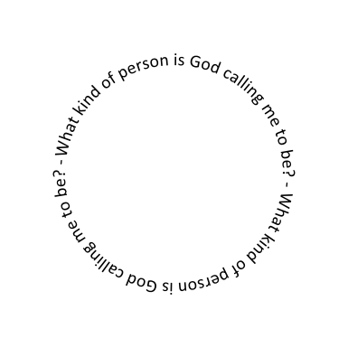

PSHE –

Online Safety

Road Safety

Young Carers

Feeling inside-out

Anti-bullying

Wellbeing

Finances (Maths)

Bird Builds a Nest

National Geographic: British Birds

Owl Babies

The Robot and the Bluebird.

Narrative

Non Fiction report on birds.

**“Whatever you do, work at it with all your heart… It is the Lord Christ you are serving”**

**Psalm 51 : 10**

Sculpture and mixed media

Naming primary and secondary colours, talk about colour changes, use different collage, select tools for an effect, discuss how to make a large collage, discussing likes and dislikes of their work and others.

**YEAR 2**

**Options for the poor and vulnerable**

SPAG focus – grammar, spelling, sentence cards

Use of –ing verbs / Time adverbials (His / RE)

Planning

Proof Reading and Editing

Character Study and Character Maps

Use of h/f words in dictated sentences

End of day book :

‘James and the Giant Peach’

DEAR Library books

Guided Reading: Comprehension &

Inference

Project X

**Events beyond living memory: The history of flight, Know who invented flight, when flight began, how it changed the way of life, the Wright brothers, the start of hot air balloons.**

**Music – M1 M2 M3 M7**

**I want to play in a band. Exploring rock music and developing playing instruments as a band.**

Revision of all prayers

Daily prayers / Prayer to the Holy Spirit / Prayer to the Guardian Angel

Going on a trip to RAF Cosford museum

<https://humanrights.gov.au/introhumanrights/>

Is it okay that some people have more than others?

Whose responsibility is it to care for the poor and vulnerable?