Core Text

**Big Questions**

Art –**Painting and Mixed media**

Different ways to apply paint.

Create 3D effect when painting.

Colour mixing

Science

**Scripture Focus:**

**Prayer Focus**

**Fantastic Finish**

**English**

Other Texts

Writing Opportunities– **CE1/ CE2/CE3/CE5/CE7/VPG7/VPG9/**

Computing –  
Differences between hardware and software

Use search engines effectively

Online-Safety- keep passwords safe

Maths

Times table focus - TT rockstars MD1

Fractions - Equivalence F1, counting in hundreths F2, problem solving F3, Adding or subtracting fractions F4

Time: read, write and convert between analogue and digital/ 12 and 24 hour clock M5/6

**R.E.**

**SMVSC**

**Corporal Works of Mercy**

Feed the hungry, give drink to the thirsty

P.E. **Gymnastics**

Compose and perform a 6 element sequence.

Create a sequence in unison

Perform existing sequence to be judged.

**Stunning Start**

**Virtues**:

**Compassionate and Loving**

Spoken Language – **SL8**

Other Reading

**Unit D** Christmas

**Unit B** Jesus taught us how to pray

Arrange classroom in rows mirroring a Victorian classroom. Boys on 1 side and girls on the other. Treat the children like Victorians.

**Collective Worship focuses**

Caritas in Action – ‘Options for the Poor   
& Vulnerable’ p. 144 - 161

Light

* I need a light to see in the dark
* Light is reflected from different surfaces.
* Reflection in a mirror
* How a shadow is formed.
* Exploring the size of shadows
* How to protect your eyes from the sun

**Caritas in Action**

Options for the Poor & Vulnerable

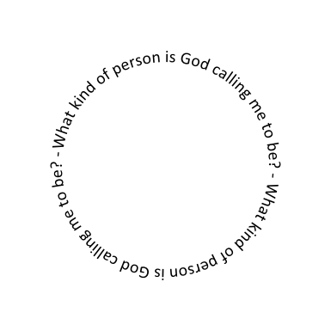

Non-fiction texts relating to chocolate and the industrial revolution.

**W1/C2/C4/C5/C6/C7/C8/C10/C12**Charlie and the Chocolate Factory – Roald Dhal

The Victorian era on a timeline.

History of Cadbury World.

Working conditions and child labour in the Victorian times

Bourneville.- History and what it is like today.

“Here is the light you will reveal to the nations”  
**Luke 2: 32**

PSHE –

A Community of Love.

What is the Church?

How do I live others?

Economic wellbeing- career

**Ten:Ten**

**YEAR 4**

**Options for the Poor  
& Vulnerable**

History – Cadbury H1,H3,H6,H7,H8,H9

Setting Descriptions CE5

Character descriptions CE5

Letter of application CE1/CE2/ CE4/VPG1/3 VPG4  
Newspaper article about the Golden ticket VPG9 VPG2

Theme link Cadbury Family history fact file - CE6 T4/ VPG4

Music –

M7/8 - listening to music for pleasure. Listening to music from Charlie and the chocolate factory Musical

Charanga- Stop (Bullying) Composing their own song.

Traditional Prayers for Year Group

Individual prayer focus (using class prayer book)

**Prayer to the Holy Spirit.**

Victorian Day in school

Speech to persuade Willy Wonka to give you the final golden ticket. CE10

Library books  
Historical texts  
Class Library

<https://humanrights.gov.au/introhumanrights/>

Should everyone have the right to employment?

Why is it important to follow rules and regulations?